TEANECK FARMERS MARKET (2024)
RETAIL FOOD ESTABLISHMENT
TEANECK HEALTH DEPARTMENT
818 TEANECK ROAD
TEANECK, NJ 07666
(201) 837-1600 Ext. 1500

Application is hereby made for a license to operate a retail food establishment as defined in
ordinance Sec. 17-21 of the Township of Teaneck, NJ.

FEE $__60.00__

Vendor’s Information
Business name: |  | Owner’s Name:
Phone Number: |  | Email:
Mailing Address:
City: | State: |  | Zip code:
Time Operator will be set up for inspection:
Nature of On-Site set up: (Food truck – Trailer – Table) Other: _________________

Food Preparation/Information
Menu: List food items to be prepared/Sold
Where is food purchased? (Please keep invoices)
Where are you holding Potentially Hazardous Foods (PHFs)? If applicable. Ex: Cold foods at 41F or below. Hot foods at 135F or above after cooked.
Cold Holding Equipment:  Refrigerator – Cooler with ice – Freezer  Other: _____________________________ |  | Hot holding equipment:  Stove – Steam table – Oven – Grill  Other: ___________________________
Where will food be prepared? Please provide proof of commissary and fill out next section.
Commissary/Servicing Area Name and Phone #: |  |  | Address:
City: | State: |  |  | Zip Code:
Please note: Food prepared at home is prohibited. All food preparation prior to event must be done at a licensed kitchen.

Documentation Needed:

- Food Manager/ Food Handlers Certification
- Business License
- Last Inspection report
- Commissary License – If applicable
- Commissary Inspection Report – If applicable

- Please reach out to the Fire Department, as depending on the type of prep (propane, grill etc.) you may have to obtain permits from them as well.

- The following set up is required and expected at time of inspection:

Temporary On-Site set up:
- Temporary handwashing station must be set-up and be accessible. A container full of warm water with a spigot type dispenser, soap, paper towels, a wastebasket, a container to collect wastewater. *See image next page
- Sanitizers (Bucket/Spray bottle) must be set up for prep areas with their proper test strips (Chlorine (50ppm – 100ppm), Quaternary Ammonium (200ppm – 400ppm), or Other ___________________
- Temporary Wash/Rinse/Sanitize set up. *See image below
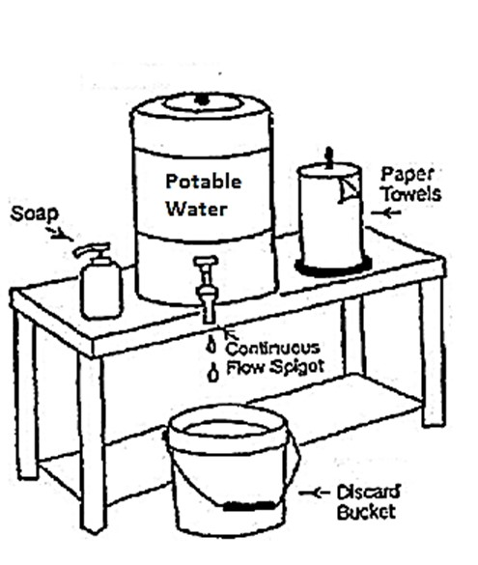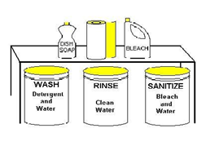

- No Ill/Sick food handlers permitted.
- Bare handed contact with Ready to Eat (RTE) foods is not permitted.
- Proper separation of raw meats, poultry from RTE food is expected to avoid cross contamination.
- Proper reheating to 165F or above is expected before hot holding at 135F or above. Hot holding units may not be used for reheating.
- The use of thermometer is required to monitor proper temperatures.
- All in-use equipment, utensils and single service items must be maintained in a clean sanitary condition.
- All in-use equipment, utensils and single service items must be maintained in good condition (no chips, etc.)
- All food products must be kept at least 6 inches off the floor.
- All areas of set up/station(s) must be kept clean, free of litter with an adequate amount of receptacles/Garbage containers.

- Please do not hesitate to contact us if you have any questions

- In consideration of such license, applicant agrees to comply with the statutes, ordinances, rules, & regulations
of New Jersey Department of Health and the Township of Teaneck.
- Applicant further agrees to permit the representative of the Teaneck Health Department to collect for
examination, samples of any food or product intended for human consumption, kept on the premises.
- Applicant further agrees immediately to advise the Teaneck Health Department of any contemplated change
pertaining to the information provided on this application.
- License, if granted, is upon express condition of forfeiture or revocation of license if the license, his agent or
servant shall violate the agreements set forth herein.
---------------------------------------------------------------------------------------------------------------------
Office Use Only

LICENSE #__________________ DATE OF ISSUE_______________________

